**Steps:**

Method 1 (Using partition): -

1. Show Swap partition using swapon -s-



2. We can check swap space using free command-



3. Check available disks & partitions using lsblk-

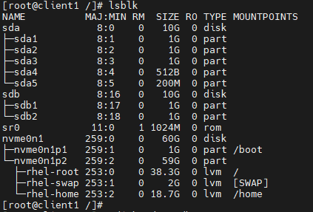

4. Create new swap partition of 1GB in size using gdisk-

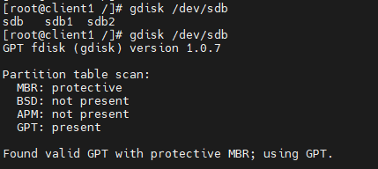

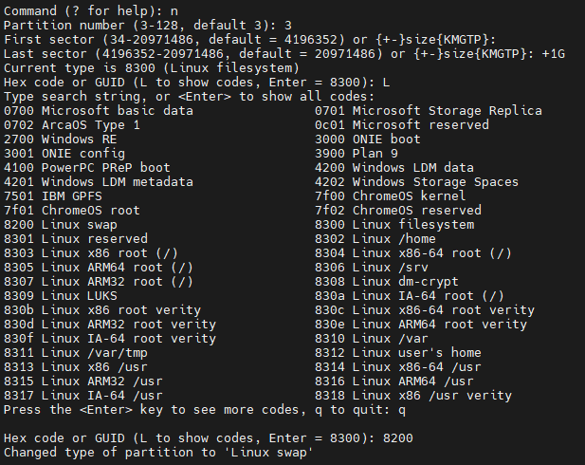

Here Hex code 8200 is used for Linux Swap.

5. Now write to disk as shown-

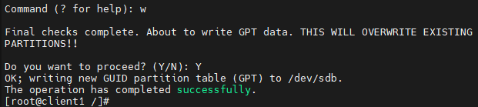

6. Run partprobe command to get kernel knows about this partition.

7. Check the created partition-

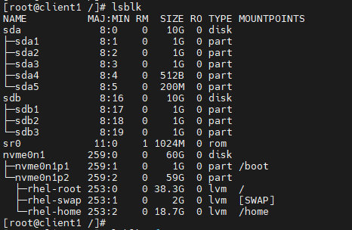

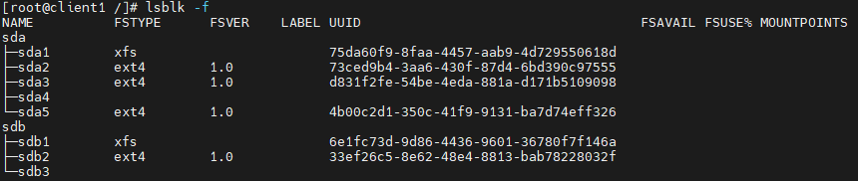

It is still not assigned with any file system yet.

8. Mount it with swap file system & verify as shown-



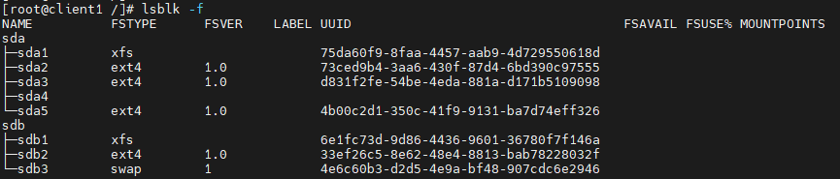

9. Now we have to enter its UUID (which can be obtained as shown in screenshot) & other details in /etc/fstab file-



10. vim /etc/fstab



11. To mount this newly created swap, use command as shown-



12. Finally show the new swap partition & total size after adding 1GB swap-

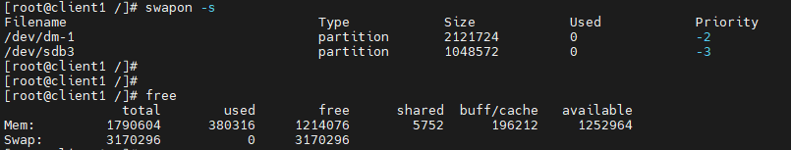

13. If we want to remove this increased 1GB swap space temporarily, use swapoff command as shown-

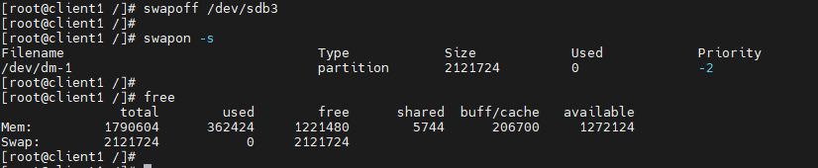

14. To remount back, run swapon -a.

15. To remove permanently, delete its entry from /etc/fstab file.

Method 2 (Using Swap file): -

1. To check statistics of swap, we use vmstat. We need to install its package first-



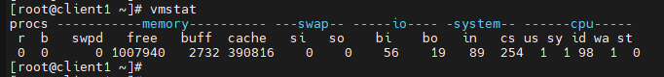

2. Currently there are no additional swap mounted as shown-

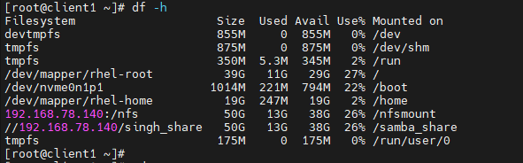

3. Now we can create swap space using file. Make sure you have sufficient space in that partition where you are creating these swap file (In my case, I am using /). Now create & verify swap files as shown-

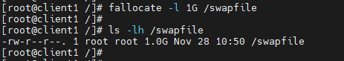

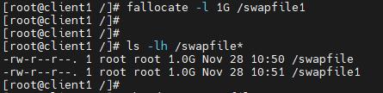

4. We have created two swap files of 1GB each. Change the permission to 600 to avoid giving access to other user-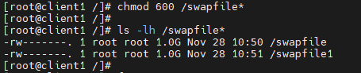

5. Check swap size currently before creating these swap-

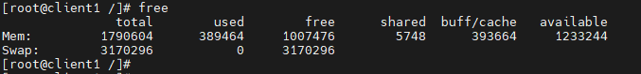

6. Create swap using swapfile created earlier & get their UUID-

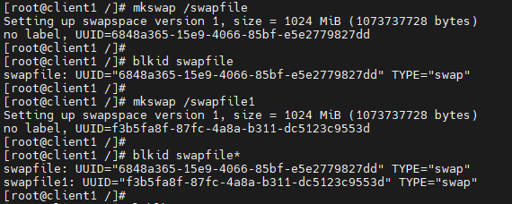

7. If we check current disk partitions, we will not see these swapfiles there. The reason is, lsblk shows us only blocks, not files-

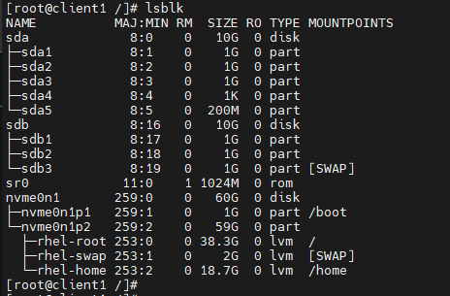

8. We can verify currently available swaps using command shown as-

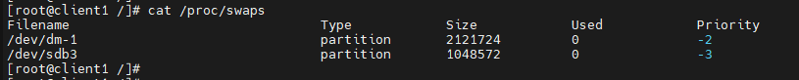

9. Make first file as swap & verify new available swaps as well as new swap space (Note: This method temporarily create these swap space)-

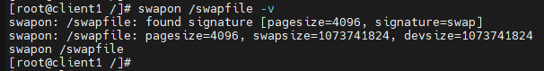

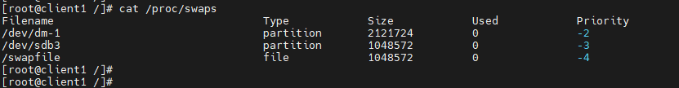

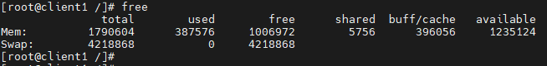

10. Similarly, make second file as swap & verify new available swaps as well as new swap space –

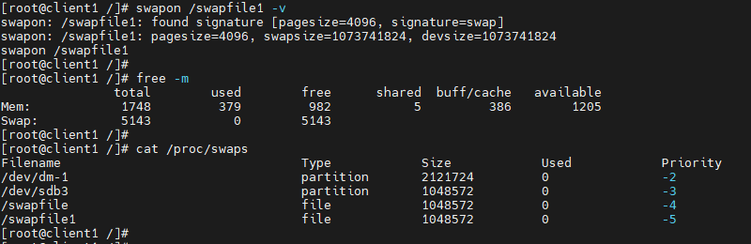

11. We can verify the same using top command-

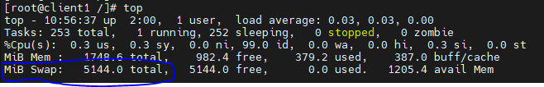

12. Now remove these swaps, which was created using swap files & verify it- 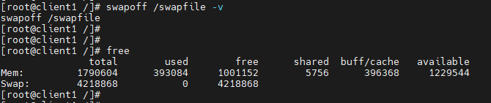

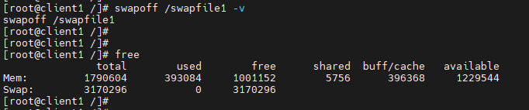



13. To make it permanent we need to add their entry in /etc/fstab file-



Swapiness: -

2. Check swapiness (If it is too low, swap will not be use & if it is high, max swap is used)-



3. We can change it temporarily as shown-

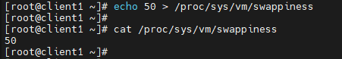

To change it permanently, we need to edit it in /etc/sysctl.conf file as shown-



